REMOTE CONTROLLED AUTOMATED

SLAG REMOVAL TOOL

NAME : RAJDEEP SINGH NAME : KETAN RAI

REG NO : RA1711002020113 REG NO : RA1711002020119

DEPT : MECHANICAL DEPT : MECHANICAL

YEAR : 3RD YEAR YEAR : 3RD YEAR

GUIDE : MR.K.EASWARAN

*Abstract*— This project aims to collect the slag from induction furnaces, pouring ladles and also to reduce accidents in foundries, steel plants and wherever slag is to be removed. Currently the operation used worldwide in small and medium scaled foundry industries is to first add the slag powder ( eg , slax 30) which binds the slag together then skimming of the slag through metal rod and then throwing into the waste bin, this process of throwing the slag is dangerous for the workers who have to check the temperature before casting and also for the employees present in that area which makes it a hazardous environment. To prevent this we have designed a tool which will pick up the slag without touching molten metal can be operated manually or through RF control. Slag can be separated easily without causing any accidents.

Keywords—Slag powder , Slax 30, Casting, Skimming, hazardous

# 

Slag removal is a primary requirement in foundries for reduction in defects .This process is very dangerous for the employee standing near the furnace., as some of molten metal liquid droplets may fall on them while removing slag, for the sake of security , this tool has been designed.

This tool acts as an industrial tool as well as safety equipment.

This device can be operated manually and can also be automated through motor and controlled through RF controller through Arduino.

This device has two key parts

1Mechanical design.

2)IOT design.

# need for the tool

## efficiency

It collects slag from the molten metal effciently

## Safety

It provides safety for the employee

III Problem statement

A)An automated tool capable to pick and remove slag from pouring ladle or furnances without touching molten metal , operated through RF control, preventing accidents for near by emplyees in the industry.

B)This tool act as a safety device and an Industrial tool.

C)The tool is user friendly and is easy to handle.

D)It can be operated through RF controller such that employee doesn’t have to go near the pouring ladle and can easily remove slag.

# E)This kind of device protects employee and increases automation in industry

IV) PROPOSED MECHANICAL DESIGN

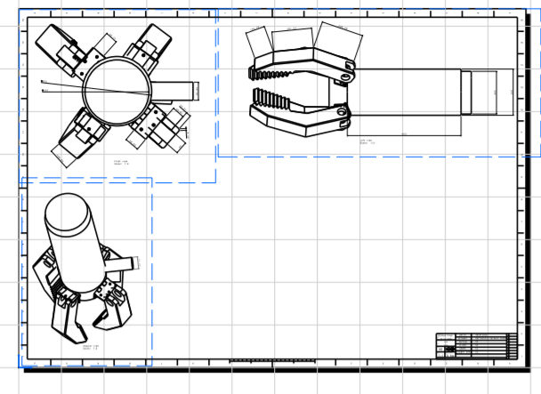

Specification

Material mild steel ,, CI

Coating on tip (Al2O3)

Total weight approximately 7 kg

Force required to reciprocate the slider 80 N

Components

1. Hollow cylinder
2. Slider
3. 4 hinges
4. Tongs ( tip coated with Al2O3)
5. 4 spring

ADVANCED MECHANICAL DESIGN

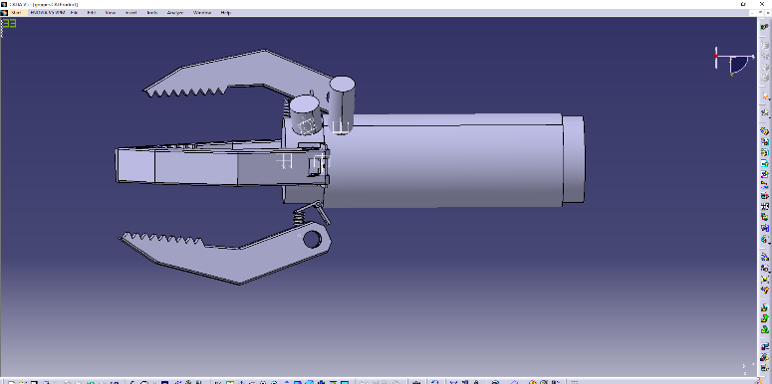

V)FREE BODY DIAGRAM

mg sin 45

kx mg cos 45

friction Force

## VI) Equations and calculation

Mass per component = 1.5 kg

Weight of slider

Mg sin45= 10.4 N

Mg cos 45 =10.4 N

Coefficient of friction ( U=0.6N)

Normal reaction (N*=14.715)

Displacement of spring =10 cm

A)To find stiffness

Kx = Mg cos 45

K=147.15 N/M

B)friction force = UN

Normal reaction * coefficient of friction

14.715*.6 =8.829 N

C) force required to reciprocate the slider per tong (F)

MgSin45-f=F

10.4-8.829=1.571

Force for 4 tongs = 1*

# VII) working of mechanical design

1)Hollow cylinder has 4 hinges weld to it at the end ,

tongs are weld to the hinges

2)Springs are weld to the tongs and the base cylinder.Slider slides on the base cylinder.

3)In the initial form spring provide tensile force to move. keep arms open

4)When slider pushes the hinges through with worth quick return mechanism attached with motor controlled by IR sensor , spring compress , tongs picks the slag without touching molten metal,which is then dumped in bin .

VIII) Proposed IOT design

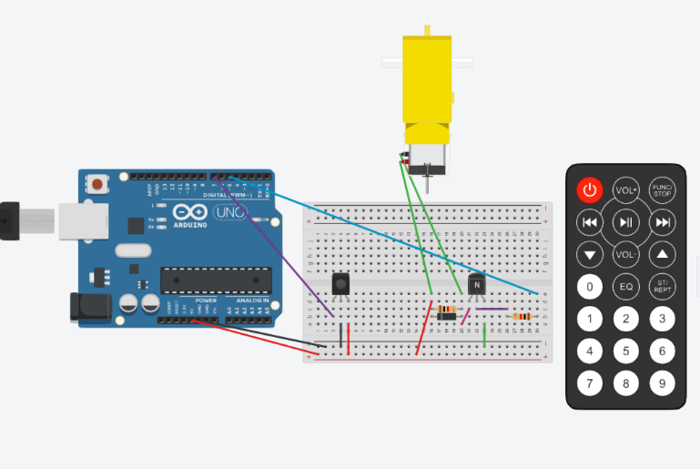

Components

1)Arduino (UNO)

2)Bread board

3)IR sensor

4)NPN-transistor(bjt)

5)2 resistors

6)Diode

7)Motor

7)Motor

8)IR remote

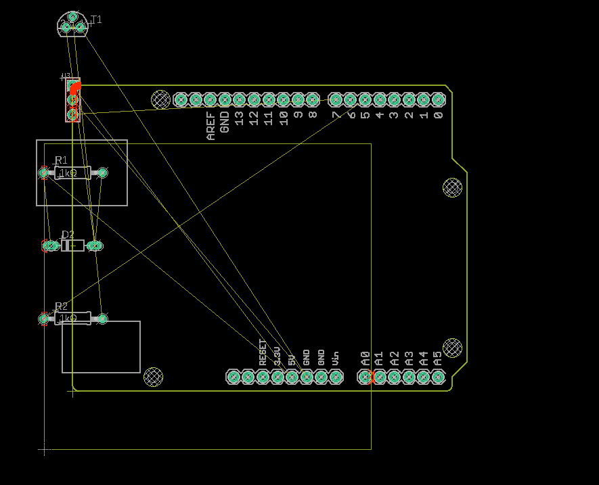

IX) Working of IOT system

* Firstly we can connect IR sensor to Arduino Uno.
* Connect the left pin of IR sensor which is ground to the ground of the Arduino
* Connect the middle pin which is 5V input to the 5V output pin of the Arduino.
* Connect the right pin which is signal output pin to the digital pin 2 of the Arduino

.

## IX) Connections are as follows :

* Connect enable pins (Pin 1, Pin 2) of L293D to 5V output of Arduino. This enables two H-Bridge channels inside the IC to drive two DC motors.
* Connect logic voltage input (Pin 16) of L923D to 5V output of Arduino. This defines the voltage (5V) logic of control signals .
* Connect motor/drive supply (Pin 8) of L293D to +ive of the 9V battery.
* Connect ground pins (Pin 4, 5, 12, 13) to ground of Arduino and -ive of the battery.
* Connect pin 2 of L293D to digital pin 6 of the Arduino.
* Connect pin 7 of L293D to digital pin 5 of the Arduino.
* Connect pin 10 of L293D to digital pin 11 of Arduino.
* Connect pin 15 of L293D to digital pin 12 of Arduino
* Connect first DC motor to Pin 3 and Pin 6 of L293D.
* Connect second DC motor to Pin 11 and Pin 14 of L293D.

#### X)Coding

#include <SoftwareSerial.h>

#include <IRremote.h>

#include <IRremote.h>

int RECV_PIN = 7;

IRrecv irrecv(RECV_PIN);

decode_results results;

const int MOTOR=5; //Motor on Digital Pin 5

void setup()

{

Serial.begin(9600);

irrecv.enableIRIn(); // Start the receiver

Serial.println(results.value, HEX);

irrecv.resume(); // Receive the next value

pinMode(MOTOR,OUTPUT);

}

void loop()

{

if (irrecv.decode(&results)) {

Serial.println(results.value, HEX);

irrecv.resume(); // Receive the next value

for (int i=0; i<256; i++)

{

analogWrite(MOTOR,i);

delay(10);

}

delay(2000);

for (int i=255; i>=0; i--)

{

analogWrite(MOTOR, i);

delay(10);

}

delay(2000);

}

}

XI)Mechanical + iot design

